

The International Association of Lions Clubs
District 105D
Incorporating Lions Clubs International District 105D Charitable Trust
Registered Number 1072984

District Governor 2014 - 2015  Lion Mike Hendy
 dg@lions105d.org.uk  www.lions105d.org.uk

“Teamwork, Leadership and Compassion”

18, West Court, West Drive, Sonning, Reading, Berks RG4 6GL
Tele: 0118 969 3930 Mobile: 07917 300999 Email: patrick.hamblin@btinternet.com
20th February 2015
Dear Lion President,

Lions Clubs International Foundation (LCIF)

I would like to open by thanking on behalf of LCIF all the Clubs that have donated to various LCIF projects this Lionistic year. District 105D has raised more to date in this period than any other District in MD105.

Haiti: One of the comments I receive is that there is only limited feedback from LCIF. Many of the LCIF projects are large, involve Clubs in areas where feedback can perhaps be described as a little slower than in other areas and are long-term. However, some very good news on Haiti is that our contributions are funding the reconstruction of the Montfort Institute. This was founded in 1957 and serves the deaf and mute community. However, it was completely destroyed in the 2010 earthquake. LCIF and Lions have chosen to funds the reconstruction of the vocational training buildings. One area is designated for girls and includes training in cooking, baking, and sewing and a stock room. LCIF and Lions funding also covers a prefabricated structure for the boys’ vocational training that includes teaching skills such as carpentry and ironwork. Construction of the buildings is underway but progress is not as fast as we might expect if it was in the UK!The project is being monitored by LCIF and local Lions Clubs. I am attaching some photographs for information.

Melvin Jones Fellowships (MJFs): In my letter included in the December mailing I set out the new arrangements for obtaining Melvin Jones Fellowships. I know both first hand and from other Lions that these arrangements are working well and there does not seem to be any additional charges if only one MJF is ordered at a time. Please get in touch with me if you are having any problems when ordering on-line.

Bert Mason Humanitarian Award: these can be obtained from MDHQ under the new arrangements.

Measles and Rubella Initiative – ‘One Shot One Life’: I have written to you previously (in the August District mailing) regarding the ‘Lions One Shot One Life Appeal’ to prevent up to 400 children dying every day from measles and rubella. I do hope that, if your Club has not donated this Lionistic year already, it will be able to support this special appeal, where your Club’s donation will be doubled by a combined donation from the Gates Foundation and our own Government through the Department for International Development. This appeal is also the District Governor’s spouse’s appeal this year. Any cheques should be made payable to LCI District 105D and endorsed on the back ‘LCIF Lions Measles Initiative’. All donations for the Lions Measles Initiative are eligible to count towards Melvin Jones Fellowships.

Kind regards.
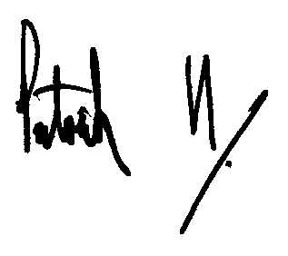

Lion Patrick Hamblin

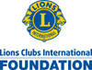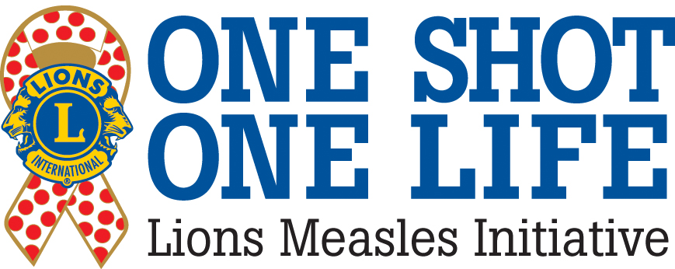

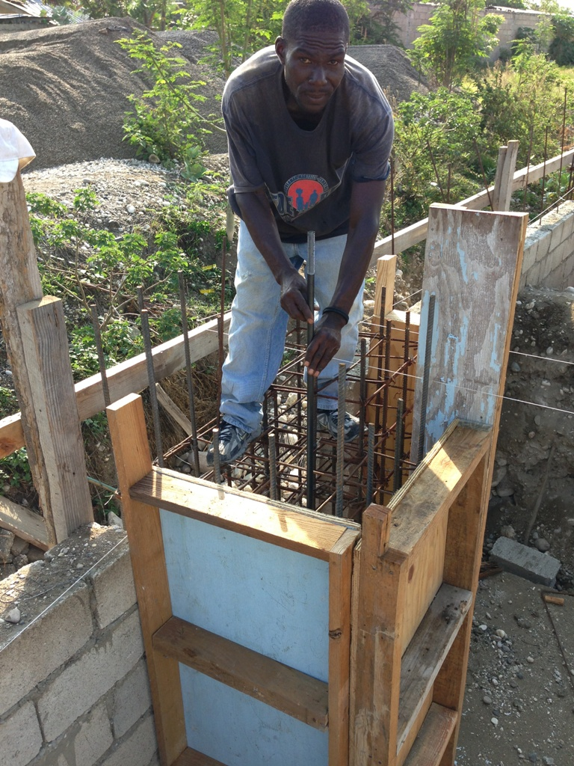

Construction begins.

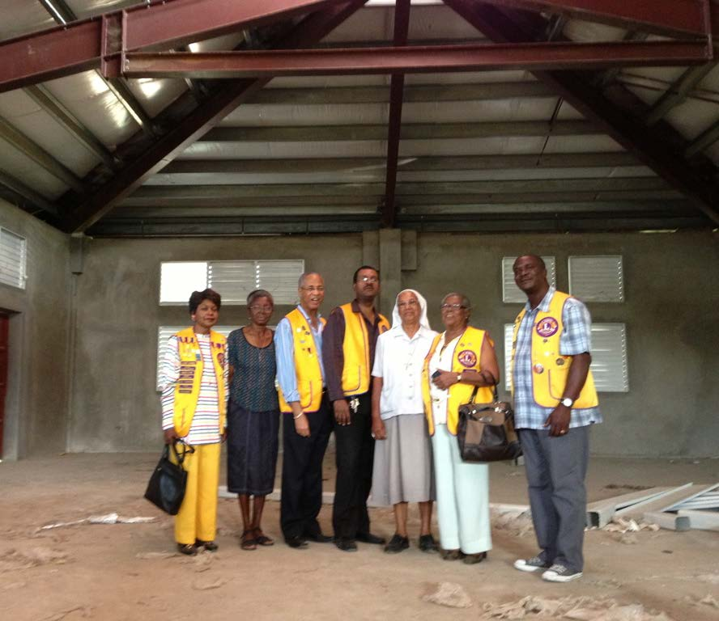

One building with general structure complete.

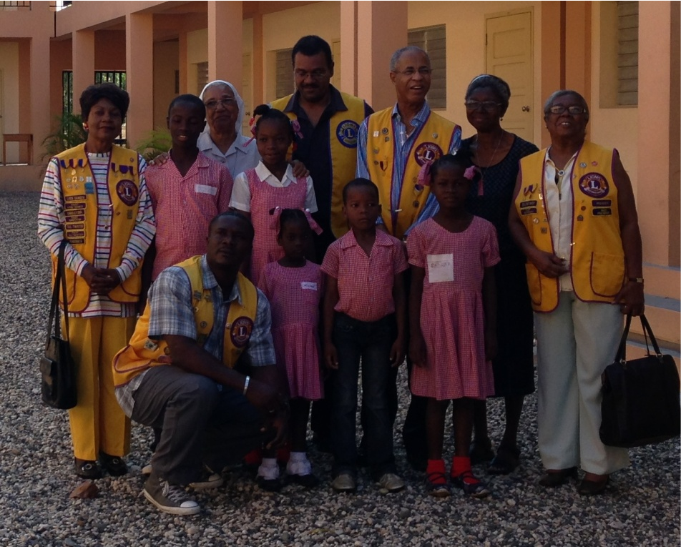

Students and Lions in front of the academic buildings (funded by others).

